The laboratory work 2
Building an application
Create new Xamarin application and make Mobile Android application as a start project. Choose an emulator from the list of emulators and make sure it is ready to start.
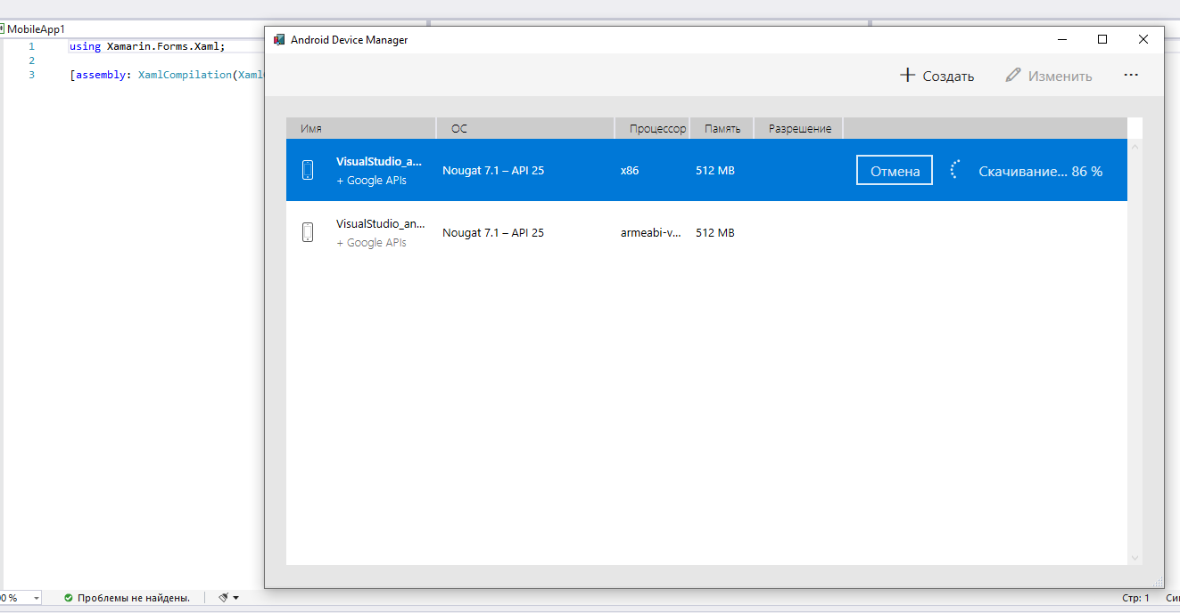
In the created application add Xaml page
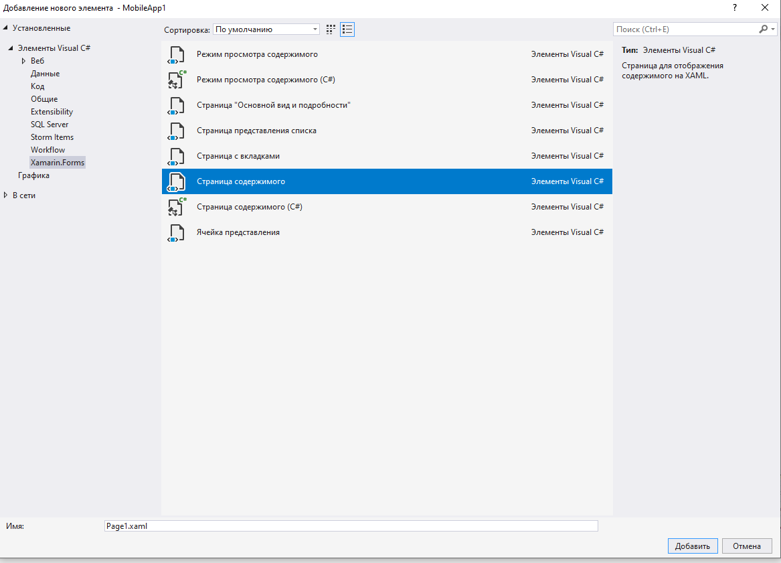
Two files have been created Xaml and C# file (cs).
<?xml version="1.0" encoding="utf-8" ?>
<ContentPage xmlns="http://xamarin.com/schemas/2014/forms"
xmlns:x="http://schemas.microsoft.com/winfx/2009/xaml"
xmlns:d="http://xamarin.com/schemas/2014/forms/design"
xmlns:mc="http://schemas.openxmlformats.org/markup-compatibility/2006"
mc:Ignorable="d"
x:Class="MobileApp1.GreetPage">
<ContentPage.Content>
<StackLayout>
<Label Text="Welcome to Xamarin.Forms!"
VerticalOptions="CenterAndExpand"
HorizontalOptions="CenterAndExpand" />
</StackLayout>
</ContentPage.Content>
</ContentPage>

using System;
using System.Collections.Generic;
using System.Linq;
using System.Text;
using System.Threading.Tasks;

using Xamarin.Forms;
using Xamarin.Forms.Xaml;

namespace MobileApp1
{
[XamlCompilation(XamlCompilationOptions.Compile)]
public partial class GreetPage : ContentPage
{
public GreetPage()
{
InitializeComponent();
}
}
}

We will create an action button on the page

<?xml version="1.0" encoding="utf-8" ?>
<ContentPage xmlns="http://xamarin.com/schemas/2014/forms"
xmlns:x="http://schemas.microsoft.com/winfx/2009/xaml"
xmlns:d="http://xamarin.com/schemas/2014/forms/design"
xmlns:mc="http://schemas.openxmlformats.org/markup-compatibility/2006"
mc:Ignorable="d"
x:Class="MobileApp1.GreetPage">
<Button HorizontalOptions="Center" VerticalOptions="Center" Text="Click this text" Clicked="Button_Clicked">
</Button>
</ContentPage>

using System;
using System.Collections.Generic;
using System.Linq;
using System.Text;
using System.Threading.Tasks;

using Xamarin.Forms;
using Xamarin.Forms.Xaml;

namespace MobileApp1
{
[XamlCompilation(XamlCompilationOptions.Compile)]
public partial class GreetPage : ContentPage
{
public GreetPage()
{
InitializeComponent();
}

private void Button_Clicked(object sender, EventArgs e)
{
DisplayAlert("Сообщение", "Message", "OK");
}
}
}

Build and run the created application under the simulator

